••The line plot illustrates the **daily price trends** of three key commodities—rice, wheat, and vegetables—over a 30-day period, showcasing natural market fluctuations.

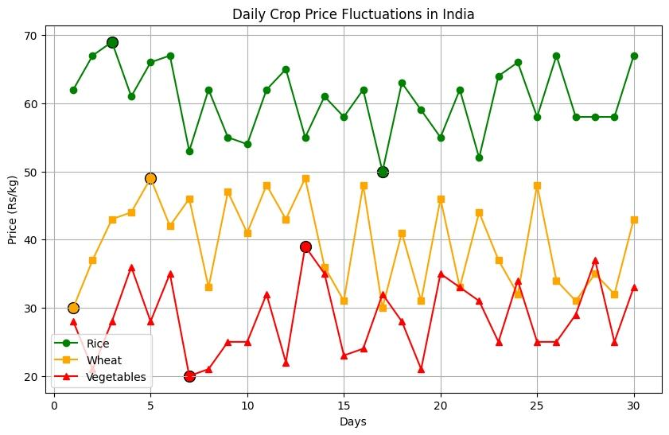

••This analysis of crop price fluctuations is essential for farmers and buyers **to understand market trends**, allowing them to make informed decisions on when to sell or when to purchase commodities.

••By tracking these fluctuations, buyers can take advantage of low prices for bulk purchases, while farmers can identify **optimal selling periods for better profit margins.**

••Market volatility highlights the need for a stable supply chain and **timely information**—an online platform can facilitate **real-time updates** on pricing, empowering both farmers and buyers.

••Such a platform can help **minimize losses** due to **price uncertainty** by connecting farmers directly with buyers, providing them with tools to negotiate better rates based on current data.

•• This system not only enhances **market transparency** but also helps **strengthen the agricultural economy** by reducing the **dependency on middlemen**, thereby improving the **financial security of farmers and buyers alike.**